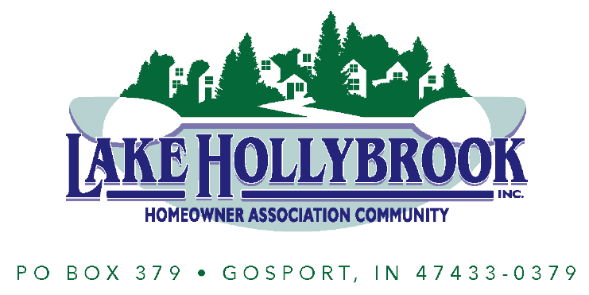
Letter Of Understanding and Liability Waiver for Clubhouse Rental
This Liability Waiver is effective ___________________, _________________________________(the “Party”) who acknowledges and agrees to the terms below:
_{TERMS AND CONDITIONS}
- The Party willingly rented the Lake Hollybrook Clubhouse, Gazebo, and surrounding yard.
- The Party is aware and acknowledges that Lake Hollybrook Homeowners Association will not be held responsible for the risk and hazard that may arise during this activity.
- Lake Hollybrook Homeowners Association will not provide any compensation to the Party OR THEIR GUESTS should a risk or hazard arise.
- The Party expects no compensation, bonus and or reward for joining the aforementioned activity.
- There is no solicitation that Lake Hollybrook Homeowners Association requires for the said activity. Therefore, the Party is responsible for their own budget and expenses during the activity.

IN WITNESS WHEREOF, the Party executes this Waiver by signing below.
Authorized Signature _____________________________________________
Print Name and Title _____________________________________________
_{CONTACT INFORMATION}
Email Address ___________________________________________________
Phone Number ___________________________________________________

